Name:
Class: Digital Media Arts Date: 11/23/15
Graphic Design- Logo “Activity Mat”
Explain what you learned about Logos: “A”=4-5 sentences, “B” = 3-2 sentences; “C”= 1-2 Sentences; “F’ = none
-
-
-
-
Why?  Students will become familiar with the objectives and needs of a client (themselves) and develop logo designs based on those goals. | When?  You have 1.5 days to complete this Activity Mat based off the Power PT & Internet searches. Submit finished to Schoology for grading. | Point to Ponder:  Why do we want to keep logos simple if we can?
Key Terms: Give definition of the vocab. Word and a graphic to match
Key Term/Vocab. | Definition | Graphic(s)
Father of Modern Graphics
Serif Font
Sans Serif Font
What is a Logo
A “GOOD” Logo should be:
Golden Rules of Logo Design
“KISS” | Keep it simple silly
Scaleable |  | 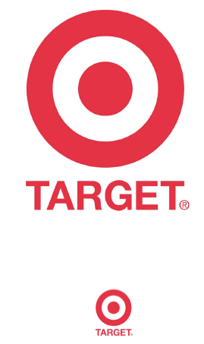
Descriptive Logos
Symbolic Logos
Importance of Colors
Importance of Fonts

