MODULE 1

Getting Started
The options made available to you for this project are listed below. These projects are student-centered and you will drive the project in your own particular direction depending upon your interests. These options are to be viewed as guides, moreover, what is of ultimate importance is that you create an original work of art. What does original mean? Let’s start with an excerpt from a recent message I got from my high school art teacher who is still teaching in Ames, Iowa, professionally judges 4H art, and is involved in a lot of online art discussions. Below are a few reasons why it is so important to do ORIGINAL artwork, for most of you this means do your own photography to draw from. Fine someone to model for you, take your own pictures, and make your own art. Copying someone else’s artwork, nearly identically, only shows me and the world that you can be kind of like a Xerox machine. That is not the outcome I want, you want, or the art world wants today. We in the art world want you to express you.
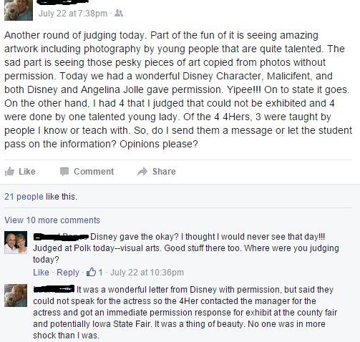

Project Options
You have 4 different options to choose from. They are fairly general in terms of subject matter; this allows you to pursue the creation of work that meets your own interests.

Option 1

“Drawing People: A Unique Perspective”
Media:
Pencil Drawing
Outcome:
Through this project you will be utilizing your learning about realism and abstraction in art to come up with an idea or concept you would like to get across through a realistic drawing. The topic of your drawing will be based around a person or people. Your work must be fully original. For instance, you might create a pencil drawing from a photograph of someone dressed up, of yourself, or a friend, etc. You will need to take a high quality photograph with a digital SLR camera and will use a photo transfer process to turn your photo into a drawing. Perspective, different and unique perspective is the key to this project option. You will learn about the photo transfer process in class and may also watch the instructional videos on our art website. See examples below.
Objectives:
I can apply the element of scale to enlarge my initial art concept.
I can use the principle of perspective to create a unique composition.
I can utilize a SLR Camera to take a sharp/clear photo and use editing software to black and white process it.
I can synthesize my old and new knowledge of drawing to create an artwork that shows:
- Sensitivity to pencil pressure in creating tone and gradient.
- I understand there are different types of graphite pencils (H, B, 2B, 4B, 6B) and each has different rendered characteristic that affect the finished contrast of the artwork.
- I can create a finished composition that has a range of tone (0% tone 50% tone 100% tone).
I can use audio/video online resources to research methods to improve my drawing techniques.
I can render a finished and technically clean artwork that demonstrates care and pride for my work.
I can create an artwork that shows I have developed my original concept and it is suitable for presentation and an audience.
I can communicate academically with my peers to improve my drawing techniques and to critique and evaluate the strengths and weaknesses in my work and their work.
I can create an artist statement that clearly explains my artistic concept and intentions for display with my work,
Size Requirements: Minimum size is 12x14 inches or larger.
Materials Required: Pencils (H, B, 2B, 6B), Smooth Drawing Paper, White Gum Eraser, Large Blending Stump, SLR Camera, SD Card, Printer, and Photo Editing Software.
DON’T FORGET TO DOWNLOAD YOUR MODULE 1 CHECKLIST SO YOU DON’T FORGET ANYTHING!

Option 1 Examples: (most examples are from high school students)
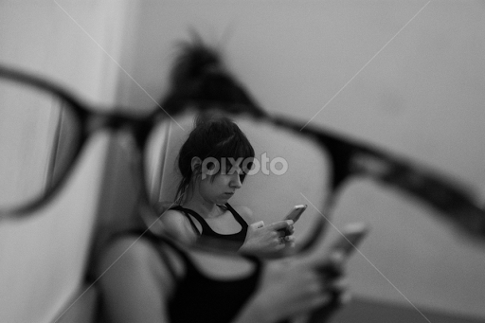 Look at the excellent ‘framing’ the artist uses here. Creates a unique perspective and draws us in. You could create a photograph composition of your own using glasses or other objects to frame the subject, just make sure your photo is sharp for your drawing.
Image Source: https://www.pixoto.com/images-photography/people/family/another-perspective-of-my-twin-sister-6309420517556224.jpg

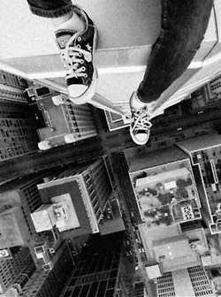 This would make a lovely pencil drawing and shows a great perspective. You could create your own photo sitting on a ledge, bridge, steps, it could be closer up. Make sure to stay safe when taking perspective shots!
Image Source: http://24.media.tumblr.com/tumblr_m4shx4tFm71qcu0ewo1_250.jpg
MORE HIGH SCHOOL STUDENT EXAMPLES BELOW FROM GOOGLE IMAGES:
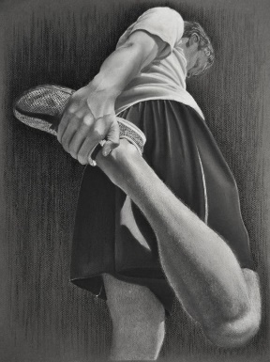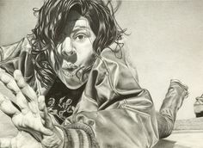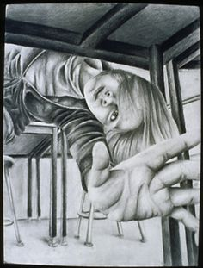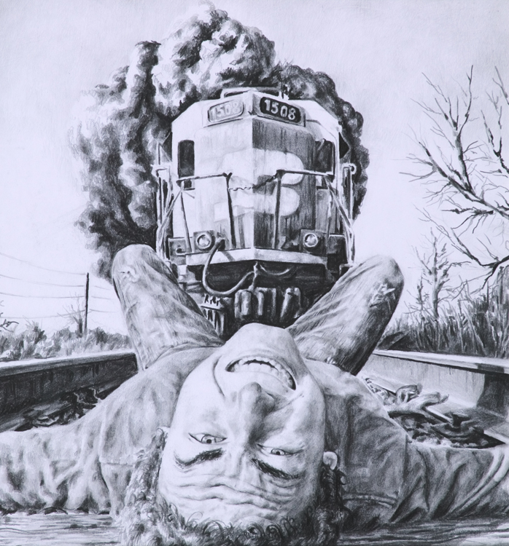

Option 2

“3D Printed Abstract Sculpture”
Media:
Computer-Based Art
Outcome:
Through this project you will be utilizing your learning about realism and abstraction in art to come up with an idea or concept you would like to get across through a 3D modeled and 3D printed abstract sculpture. The topic of your sculpture will be based around a person, place, or thing that you have abstracted. Your work must be fully original. For instance, you might create a pencil drawing, sketch, or photograph of a dancer spinning and transfer this ‘movement’ into an abstract form. You will be shown in class two methods to abstract people and objects. You will also be responsible for learning a new but basic software program to create your 3D model/sculpture. You will also need to watch the instructional videos on our art website. See examples below.
Objectives:
I can apply the element of shape/form to change a 2D image into a 3D model.
I can use the principle of balance to create a unique composition that can stand on its own.
I can utilize a SLR Camera to take a sharp/clear photo and use editing software to black and white process it.
I can synthesize my old and new knowledge of sculpture to create an artwork that shows:
- I can think abstractly to change a 2D drawing or photo into a 3D model.
- I understand the basics of 3D modeling an object through the use of spheres, planes, Taurus, cylinders, and faces and vertices.
- I can create a finished composition that is visually (aesthetically) interesting to look at.
- I can apply color theory to my 3D model to enhance its function.
I can meticulously pay attention to surface detail and texture to create a work that has a professional finish.
I can use audio/video online resources to research methods to improve my sculpture techniques.
I can render a finished and technically clean artwork that demonstrates care and pride for my work.
I can create an artwork that shows I have developed my original concept and it is suitable for presentation and an audience.
I can communicate academically with my peers to improve my drawing techniques and to critique and evaluate the strengths and weaknesses in my work and their work.
I can create an artist statement that clearly explains my artistic concept and intentions for display with my work,
Size Requirements: Minimum size is 6 inches tall printed, maximum size is 24 inches tall printed. (NOTE: objects taller than 8 inches will have to be printed in multiple sections and assembled.
Materials Required: Drawing/sketch paper, Computer, SLR Camera, 3D Printer, 3D Modeling Software, Spray Paint, and Acrylic Paint.
Examples:
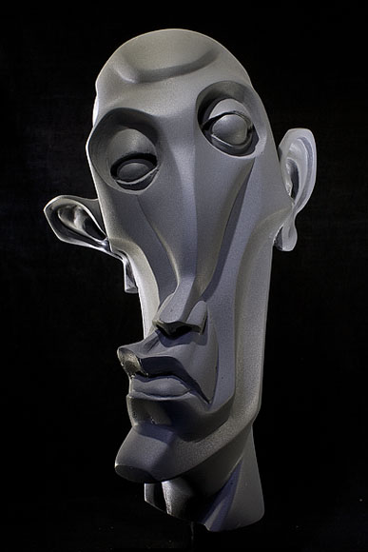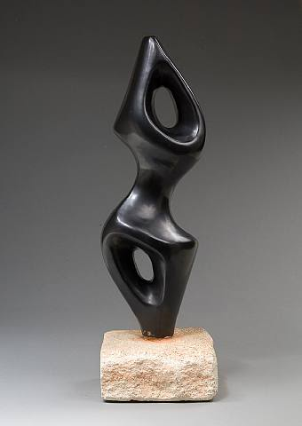
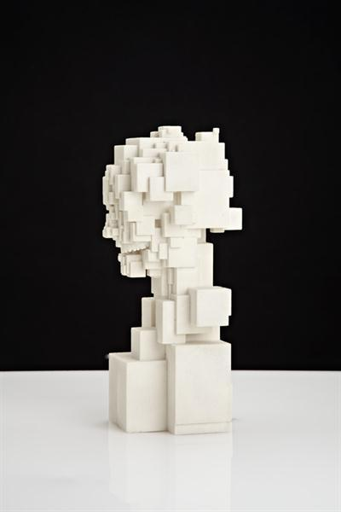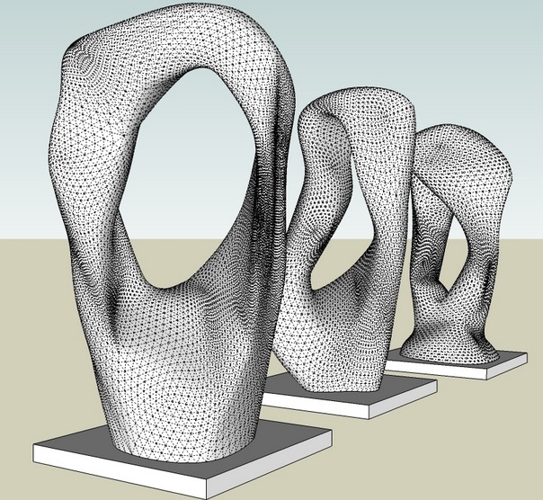

Option 3:

Traditional Sculpture: Cardboard & Paper Mache or Clay
Media:
Papers or Clay
Outcome:
Through this project you will be utilizing your learning about realism and abstraction in art to come up with an idea or concept you would like to get across through a 3D abstract or realistic sculpture. The topic of your sculpture will be based around a person, place, or thing that has purpose or meaning to you. Your work must be fully original. For instance, you might create a pencil drawing, sketch, or photograph of a dancer spinning and transfer this ‘movement’ into an abstract form. You may take a new photograph of something or use reference images from the internet to create a sculpture that is new and original. You will be shown in class two methods to abstract people and objects and one method of sculpting realistically in clay. You will also need to watch the instructional videos on our art website. See examples below.
Objectives:
I can apply the element of shape/form to change a 2D image(s) into a 3D sculpture.
I can use the principle of balance to create a unique 3D form and composition that can stand on its own.
I can utilize a SLR Camera to take a sharp/clear photo.
I can synthesize my old and new knowledge of sculpture to create an artwork that shows:
- I can think abstractly to change a 2D drawing or photo into a 3D model.
- I understand the basics of 3D modeling in paper or clay through manipulation, texturizing, and smoothing of the medium.
- I can construct basic armatures or support structures to support my work’s form.
- I can create a finished composition that is visually (aesthetically) interesting to look at.
- I can apply color theory to my sculpture to enhance its function.
I can meticulously pay attention to surface detail and texture to create a work that has a professional finish.
I can use audio/video online resources to research methods to improve my sculpture techniques.
I can render a finished and technically clean artwork that demonstrates care and pride for my work.
I can create an artwork that shows I have developed my original concept and it is suitable for presentation and an audience.
I can communicate academically with my peers to improve my drawing techniques and to critique and evaluate the strengths and weaknesses in my work and their work.
I can create an artist statement that clearly explains my artistic concept and intentions for display with my work,
Size Requirements: Minimum size is 6 inches tall or wide, maximum size is 24 inches tall or wide.
Materials Required: Drawing/sketch paper, Computer, SLR Camera, Spray Paint, and Acrylic Paint, paper Mache, wire, tape, clay, face molds, clay tools.
Examples:
